Riparian Zone Management on Private Lands
The goal of this analysis is to broadly describe the condition and extent of the “riparian zone”, to inform diffuse restoration and enhancement work necessary to restore streams, salmon, and waters supply. While “riparian zone” is commonly interpreted as a regulated vegetated buffer on a stream, more scientific definitions are broader:
Riparian areas are transitional zones between terrestrial and aquatic ecosystems and are distinguished by gradients in biophysical conditions, ecological processes, and biota. They are areas through which surface and subsurface hydrology connect waterbodies with their adjacent uplands. They include those portions of terrestrial ecosystems that significantly influence exchanges of energy and matter with aquatic ecosystems. Riparian areas are found adjacent to perennial, intermittent, and ephemeral streams, lakes, estuaries, and marine shorelines. (National Research Council 2002)

Riparian zones extend beyond streams into the watershed along ephemeral flows, through subsurface seeps, to perched wetlands. While we argue over regulations, the health of our water supply depends on how we actually manage watersheds.

Riparian zone management either aims to improve the habitat conditions in a stream, or improve the quantity and quality of water entering the stream over time. In our dry summer climate, storing winter rains to support cold summer flows is particularly important. The following general actions are repeated through thousands of pages of salmon recovery and clean water act planning documents:
- Streamside Reforestation – planting forests near streams to improve soils, shade streams, and produce large wood and leaf litter.
- Channel Restoration – remove armoring, and restore the sinuosity, riffle-pool structure, and floodplain connectivity of stream channels.
- Floodplain Reconnection – remove levees and causeways that prevent the flow of floodwater, or install wood structures that reactivate side channels and flood flow pathways. Reverse incision.
- Wetland Enhancement – retain and percolate surface runoff into soils and groundwater, by holding rain high in the landscape. The enhancement of wetland functions is achieved through a wide range of
- Watershed Reforestation and Infiltration – through education and regulation, reduce the area of roofs, compacted soils, and pavement, and maintain forest cover.
If we act sufficiently, then we will have abundant clean cold water in streams that support fish and wildlife and agriculture, ample groundwater supplies, reduced flooding, and we will increase our resilience to resilient to climate change. To maximize efficiency and effectiveness we position our action in an advantageous position in the landscape. Finding the advantageous position is a matter of strategy. Our strategies define our search image—the kinds of places where a specific action will be most advantageous.

The following analysis was completed to construct
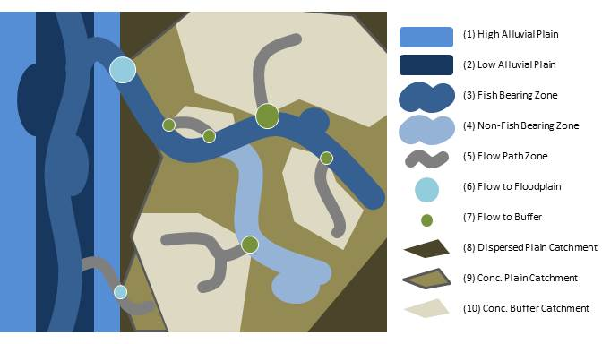
Figure 1 – Diagram of Polygons and Points Describing Riparian Systems. Alluvial Plains are distinct from Watersheds in their structure, processes and functions. Alluvial Plains are broadly divided into (1) high and (2) low elevation alluvial plain relative to flooding. Near stream zones including waterbodies identified on county inventories, are coded as (3) fish-bearing and (4) non-fish-bearing and integrate, water body polygons, and a 100 foot buffer on both water bodies and stream lines. Hydrologic flow paths (5) are derived from digital elevation models, and show where valleys concentrate and transport water from a catchment 10 acres or larger, but where the county has not identified a stream. Points are located where concentrated flows enter (6) the Alluvial plain, or (7) near stream zones. Points size and color can be used to describe associated catchments. Catchments draining to these points (8, 9 and 110) are derived from digital elevation models, describe different levels of flow concentration, and can be evaluated for their socio-ecological conditions.

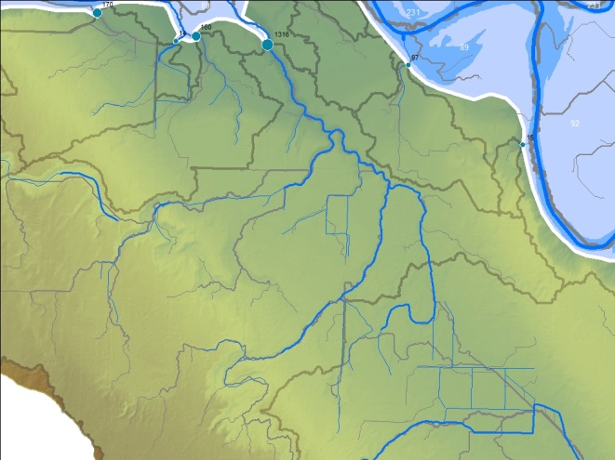  Streams and flow lines show observed and DEM-derived hydrology. Both are relevant to hydrology. Catchments flow to floodplains. Each floodplain inflow is identified by size of catchment. | 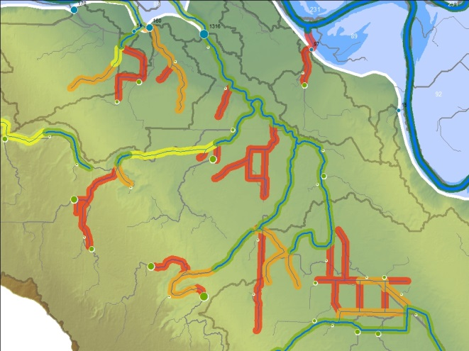  Observed stream lines have 100 foot buffers, and stream type is retained. They can be simplified.
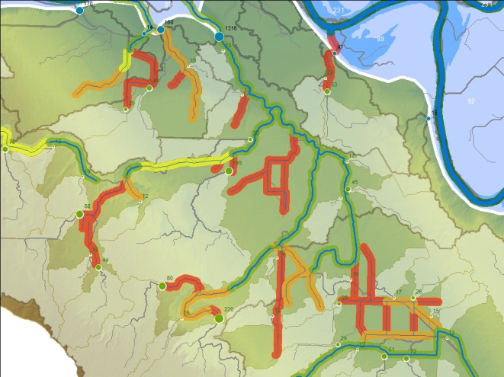  Where flow lines enter stream buffers, we have concentrated flow pathways. A significant portion of the watershed enters stream buffers at points. I’ll check out this large flowpath later… it seems interesting. | 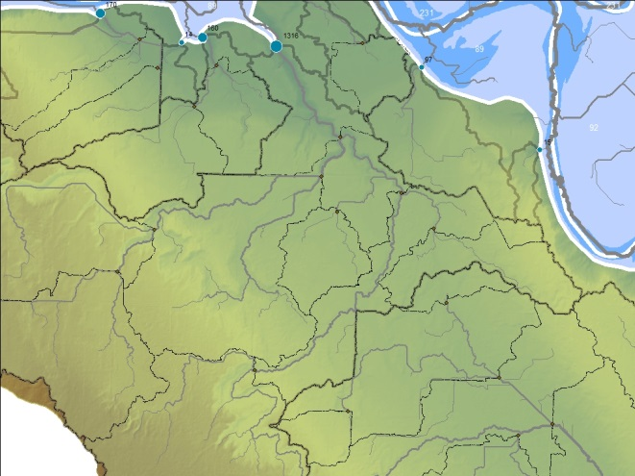  Those portions of the watershed that are not in these concetrated flow catchments are funny shaped and include all areas where less than 10 acres is concentrated at the point of buffer entry. I used a stream order analysis to identify confluence points, and subdivide the catchment by flow pathway stream order.
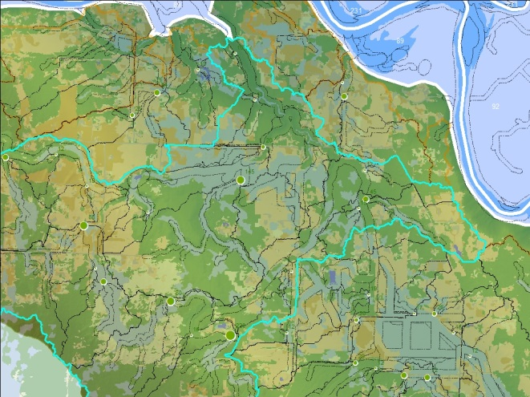  When combined these various division create a mosic of polygons. Attributes like land cover are attributed to those polygons, and condition can be summarized at any scale, or based on the attributes of the polygons. For example, “what is the riparian zone cover in all fish bearing streams for each tributary” or “what is the forest cover all the first order watesheds within among each tributary” | 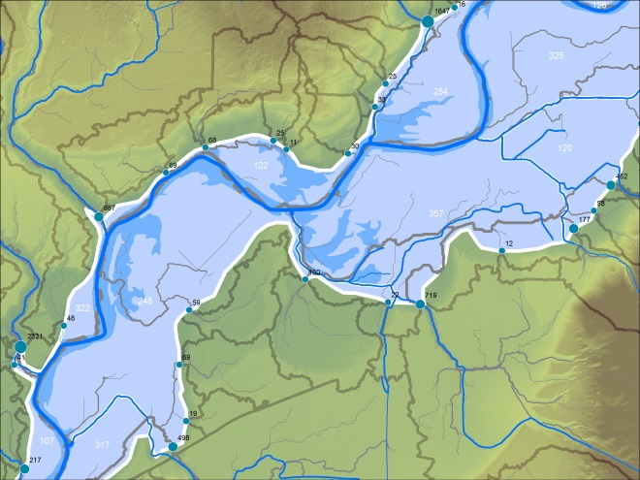  Floodplains are divided into high and low zones based on Konrad. In addition they are divided by perennial stream channel, with some hand work to combine small units, or split funny shaped units.
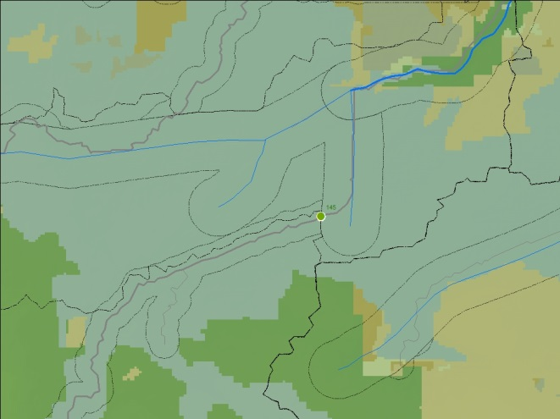  Heres a place in Glade Bekken that seemed interesting. Over 1/10 of the whole watershed enters the stream buffer at this point. | 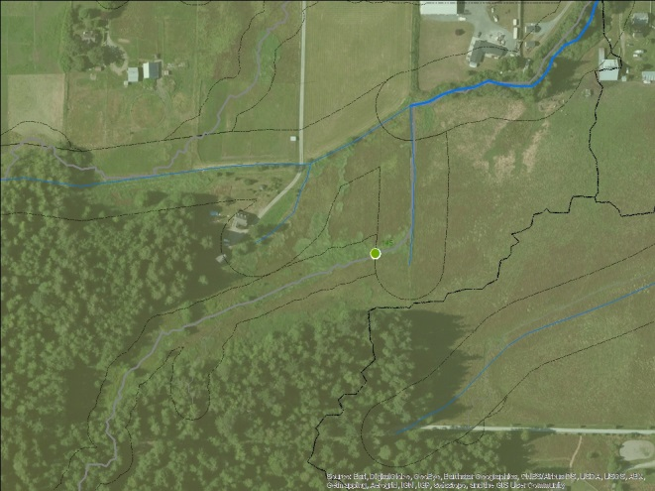  It turns out to be a set of ditched wetlands that appear very wet. Should this watershed be enhanced and protected to insure sustained groundwater flow to the creek?

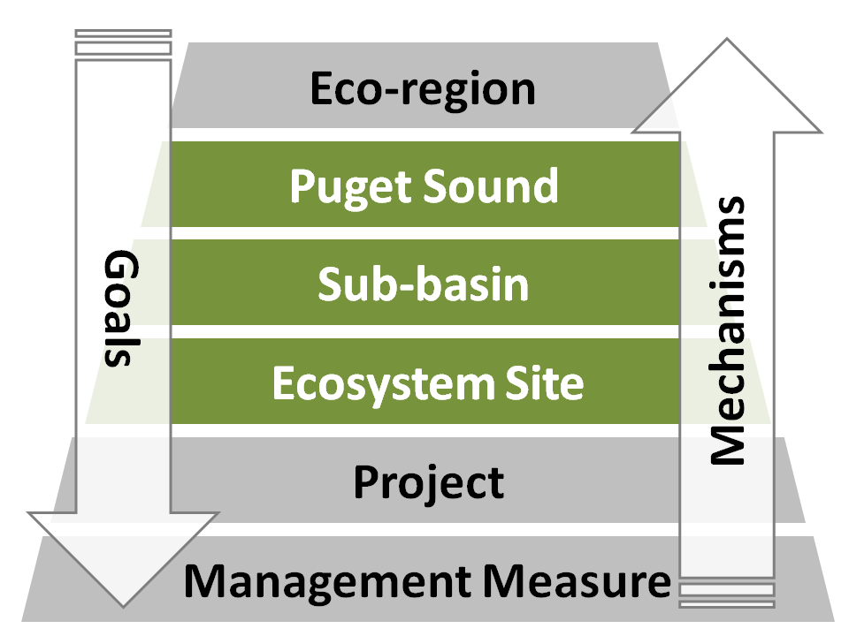

Table 1 – Integrated Hydrologic System Polygons
Attribute | Values | Function | Origin
Unit | ## | A unique identifier for each polygon
Component | Alluvial Plain, Watershed | Within the polygon framework near water areas are
Urban | Incorporated, UGA, County |  | State Ecology
System | Stillguamish, Snohomish | Defined by aggregation of Sub-Basins | Defined by the manual aggregation of sub-basins.
Sub-Basin | Snohomish Estuary, Marshlands, French Slough, Lower Pilchuck River, Middle Pilchuck River, Lower Snohomish, Lower Skykomish, Woods Creek, Lower Stillaguamish, Stillaguamish River, North Fork Stillaguamish River, South Fork Stillaguamish River, Pilchuck Creek, Jim Creek | Division of study area in the major components. | Defined by the manual aggregation of AlluvPlainID units into sub-basins, and then association of Catchments based on spatial join with Alluvial Plain units.
RMZ | Yes, No
RMZtype | Stream, Waterbody, FlowPath, Null
RMZfish | Fish, No Fish, Seasonal, Flowpath
UnitArea | ##.# acres
Alluvial Plain Units
AlluvPlainID | ##
AlluvPlainType | High, Low, Null
AlluvPlainArea | ##.# acres
Watershed Units
CatchmentID | ## | Includes both concentrated and dispersed flows to floodplains. | Derived from FlowToFloodplain Polygons merged with
FlowToAlluvPlainUnit | ## | Floodplain Unit number at input | Derived from FlowToFloodplain Polygons merged with
FlowTypeToAlluvPlain | Concentrated, Dispersed, Null | Discriminates between areas adjacent to floodplains with or without a FlowPath segment.
CatchmentArea | ##.# acres | Area in acres
SubCatchment | ##
FlowUnit | ##, Null
FlowType | Concentrated, Dispersed
FlowPathOrder | 1,2,3,4,5,6 | Number describing the maximum stream order attribute within the polygon. This describes the relative position of the polygon within the watershed.
SubCatchArea | ##.# acres
Polygon Attributes
ForestArea | ##.# acres
DevelopedArea | ##.# acres
WetlandArea | ##.# acres
ClearArea | ##.# acres
WaterArea | ##.# acres
DepArea | ##.# acres
FlatArea | ##.# acres
SteepArea | ##.# acres

- Define Study Area to include
  - Snohomish – The lowland Snohomish Basin was defined as AUs downstream of the Skykomish-Elwell confluence, and not including Snoqualmie valley in King County. Mountain AUs were only included for the purpose of capturing tributary catchments, including Woods Creek, and local headwaters to the Skykomish Floodplain described above.
  - Stillaguamish - Intended to represent lowland watersheds including Pilchuck and Jim creeks, and portions of the north and south fork mainstem. Initially a lowland AUs were included. An arbitrary cutoff was selected in the north fork to exclude the Deer Creek catchment, and mountain AUs were then included for all tributaries of the mainstem segments included.
- Create Stream Riparian Management Zone (RMZ)
  - County streams are better fit to the digital elevation model and are improvement on SSHIAP and FishDist stream linework, which is coarser in resolution and older in provenance.
  - CLIP stream features to the study area
  - DISSOLVE stream lines on WTRTY_CD which uses DNR water type
  - BUFFER to create full rounded 100’ foot buffers dissolved on water type.
  - SEPARATE BY ATTRIBUTE to create a unique feature class for each value in WTRTY_CD
- Waterbody Riparian Management Zone (RMZ)
  - SELECT ALL
  - Disconnected - SELECT BY LOCATION removing from all selected waterbodies, those that intersect the stream RMZ, with a 200’ tolerance. EXPORT to a new layer only disconnected water bodies, then invert selection, and EXPORT connected water bodies.
  - River Bars - SELECT BY ATTRIBUTE water bodies coded X, and from those, select those that are within 100 feet of a waterbody coded S (waters of the state). This is intended to select all river bars, or wetlands connected to waters of the state. EXPORT these polygons as a special feature.
  - SPATIAL JOIN the closest stream buffer water type (derived from stream line water type) for all connected waterbodies, while retaining all water bodies, and allowing for more than one stream water type per water body (to be resolved in the next step).
  - In sequence, for WaterBodies with StreamTypes S,F,Np,Ns,U,X clip underlying Waterbodies.
  - SELECT BY LOCATION water bodies
  - SELECTPut 100 foot BUFFER on all water bodies, full, rounded. With separate buffers dissolved on water type code.
  - Where waterbodies do not intersect a stream riparian management zone, they are separated from the final dataset. THIS AFFECTS THE IDENTIFICATION OF FLOW TO BUFFER, and LATER FORMATION OF CATCHMENTS… need to REDO!! ALSO EXPAND DELTA FLOODPLAIN POLYGONS.
  - The county has identified water bodies that are wetlands, or river bars, and they are coded as type ‘X’, meaning that they don’t conform to the DNR classification. How should these objects and buffers be classified?
    - Where type X buffers overlap with a classed buffer, the more protective buffer is used.
    - The area occupied by a “waterbody” is erased using the stream buffer area, so that stream buffer and water type takes precedent over stream buffer area.
    - For large rivers, the use of “water bodies”, rather than a stream line, is vital for describing an appropriate riparian management zone.
    - For the purposes of management planning we should propose four types of streams:
      - Waterbodies classified as X that intersect waterbodies typed as S or F, were lumped with their associated type.
      - Fishbearing waters and associated waterbodies with the classification ‘X’
      - All mapped streams and channels
      - Unmapped streams and channels
- Create Alluvial Plain Polygons Set
  - Attempts to use watershed formation tools to define alluvial polygons results in very complex structures. The discrepancy between channel position, and hydrologic flow path further aggregates. By contrast, dividing the landscape by stream line thalweg reflects cultural divisions of the landscape, like “what side of the river are your on”.
  - USGS analysis produced a very inclusive and broad “alluvial plain” area. The related low floodplain analysis shows areas frequently inundated by flood waters.
  - Split floodplain zone by perennial stream lines
    - Resulting polygons were coded. Any polygon less than 10 acres was merged with an adjacent polygon.
    - Polygons that were small or non-sensible compared with the surrounding landscape.
      - Where long skinny polygons bordered more than one stream system they were split.
      - Where polygons were much smaller than typical for a reach, and/or where the stream line causing the division did not indicate an observable change in land management.
      - Where Polygons along the side of a creek were excessively long, they were split, typically opposite a major tributary confluence so that polygons breaks matched on stream-right and stream-left.
  - USGS low floodplain, which uses a 10m raster as its basis, and produces too man complex polygons.
    - The low elevation component was exported to a new file.
    - Used Aggregate Polygon, with 40 foot distance, and with any polygon smaller than 10 acres discarded.
    - Smooth PAEK algorithm, with 200 foot tolerance to reduce residual blockiness. 200 feet was selected by increasing tolerance (50’ 100’, etc.) until the edges of 10m raster was obscured.
    - Resulting in 18 polygons describing low elevation zones within floodplains.
  - IDENTITY was used to attribute the Split floodplain polygon with the low elevation polygons.
  - MULTIPART TO SINGLEPART was used, revealing that 512 units were 2123
  - ELIMINATE was used to combine all polygons of less than 1 acre area with their neighbors with the longest shared border, leaving 634 floodplain units.
- Create Flow Accumulation Pathways and Buffers
  - Dissolved watersheds within the SNOHOMISH and STILLAGUAMISH STUDY AREA, and used to clip LIDAR DEM
    - In the case of Stilly, created a mosaic of 1) the Snohomish County DEM and 2) the Finlayson 2006 Puget Sound Supermosaic, for Selected AUs where coverage extends outside of the county DEM coverage.
    - The Snohomish DEM was clipped with a 500 foot overlap with the selected AUs to facilitate blending at the transition. Spot checks suggested that the difference between the the DEMs at the edge was on the order of 0.5 feet plus or minus.
    - Used [Mosaic to New Raster] tool with 1 band, 32 bit float values, and blend option for overlapping cells to create a unified mosaic for the study area.
  - Used Fill tool to remove depressions in preparation for flow direction calculation
  - Used Cut Fill tool to show area and depth of depressional features identified using Fill tool
  - Used Flow Direction tool to code filled raster.
  - Used Flow Accumulation tool to define flow pathways. No force edge cells, no drop raster.
  - Created a raster of all accumulation pathways that drain more than 10 acres of land. The DEM has 6’ square cells. An arbitrary cutoff was used such that all retained flow accumulation pathways were retained that received flow from a 10 acres or greater catchment (12,100 pixels)
    - Map Algebra, Raster Calculator, Code: OutRas = Raster("DEM_accum") > 12100
  - Stream Order, Strahler method
  - Stream to Feature, simplify polylines.
  - Dissolve and Create 50’ full buffers on resulting line work, round ends, dissolve all.
- Integrate Buffers and Interpret Water Type
  - Within river basins our “riparian zone” is a polygon made up of buffers on county stream lines, waterbody polygons, buffers to waterbody polygons, and buffers on flow paths.
  - These buffers overlap, and are further coded in terms of water-type (S,F,Np,Ns,U,X), which is important for management. However, this water-type coding is incomplete, and is applied differently among different types of objects. For example a DNR code of X are used for sand bars on large rivers, even if the river is a jurisdictional shoreline or fish bearing stream. This results in a complex and potentially misleading RMZ mosaic in these systems.
  - The following protocol was used to create buffers and resolve overlap:
    - Clip County Stream Line and County water-body layers to study area.
    - For County Stream Lines create 100 foot full buffers, rounded, and dissolve on DNR Water Type.
    - Resolve adjacency issue for water bodies coded X or U
      - All waterbodies not intersecting a stream buffer were given a special code “ISOLATED”. If not isolated, use Water Type
      - For all non-isolated water bodies, select all buffers with water type code X or U, that intersect a county stream buffer type S or F, and code as , and
    - For County WaterBody polygons, create 100 foot full and rounded buffers, and dissolve on water type.
    - Split by BUFFERCODE attribute, to produce a feature class for each buffer type and each water type, with recognizable feature name

    - Create Union of all buffers, only retaining FID
    - Export table to spreadsheet, use a series of logic statements to recode overlapping buffers based on a hierarchy of buffer-type and water-type.
      - Waterbody is preeminent followed by stream buffers, and then waterbody buffers. Watertype code is then adopted. Where watertype overlap occurs, the more protective code is retained.
    - Several simplified coding options were developed to produce a more streamlined buffer code for planning and design: Shoreline, Fish, NoFish, FlowPath
  - Join Table to Buffer Union
  - Multi-part to Single part to each buffer so that there is a single feature record for each object. For each buffer, create field value called BUFFERCODE to represent buffer type and water type.
  - Resulting floodplain layer has 385 units
  - Eliminate high floodplain units that are less than 1 acre
- Create SubCatchments based on significant stream junctions
  - ERASE Flow Path using floodplain extent. TRIM LINE to remove dangles less than 500 feet.
  - DEFINITION QUERY to exclude stream order one lines, then DISSOLVE remaining lines using stream order field
  - EDIT the resulting layer, SELECT all and then, PLANARIZE lines.
  - MULTIPART TO SINGLEPART to insure individual lines, and TRIM LINES to remove all dangles less than 500 feet in length to reduce the number of small arbitrary segments.
  - FEATURE VERTICES TO POINTS creating points at the beginning and end vertices of each feature, creating duplicate points at each junction, but also a point at the end of each junction.
  - DELETE DUPLICATE, selecting the feature type field to delete co-located points, using a 500 foot XY Tolerance, to reduce the incidence of close points and small sub-catchmetns. Retain the point with the lower stream order value (so that each point references the upstream line segment in preparation for watershed creation.)
  - SNAP TO POURPOINT with a 6 foot tolerance to match raster resolution, using feature ID to create distinct raster cells for each point.
  - WATERSHED to create point
  - C

- Create FLOODPLAIN CATCHMENTS where flow pathways intersect the alluvial plain polygon.
  - INTERSECT Flow Path with Alluvial Plain polygon, to identify pour points, with no XY tolerance
  - MULTIPART TO SINGLE PART to divide multipoint features.
  - SNAP TO POUR POINT within 6 foot radius of selected points to insure position of point on flow accumulation path. This may the effect of placing the raster pour point slightly within the floodplain polygon.
  - WATERSHED creation, using Snapped Pour Point, and Clipped Raster using FID as raster value.
  - RASTER TO POLYGON, simplifying polygon boundary
  - ERASE portions of catchments within the floodplain. In some cases, this results in creating a multipart feature where the floodplain dissects a catchment.
  - MULTIPART TO SINGLEPART was used to reduce features to individual catchments.
  - A field for acreage was added to the feature, and CALCULATE GEOMETRY to define polygon acreage using map projection.
  - Created a test feature by adding a 50 foot BUFFER to the Full Floodplain, erasing flow path lines within this zone.
  - SELECT BY LOCATION where polygons intersect the test feature (1334/2666), SELECT BY ATTRIBUTE to remove selections smaller than 10 acres, and EXPORT remaining 1103 features.
  - JOIN polygon data to point data, selecting those where the join was successful, and EXPORT to final FlowToFloodplain point layer, including catchment acre attribute.
  - These catchments vary dramatically in both size and the character of their waters within them.
- Create BUFFER CATCHMENTS where flow pathways intersect stream RMZ.
  - ERASE streams in floodplain.
  - INTERSECT Flow path with stream buffer polygon, create points
  - SNAP TO POUR POINT using a 6 foot radium to identify raster points for modelling
  - Create WATERSHED with simplified boundaries
  - Convert RASTER TO POLYGON
  - ERASE stream buffer polygon area from resulting watershed polygons
  - MULTIPART TO SINGLE PART to insure that all resulting polygons are independent and discrete.
  - CALCULATE GEOMETRY to restore accuracy of shape area field
  - BUFFER the stream buffer polygon by 50 feet, and then ERASE flow pathways within this buffer to create a line feature class that can be used to test whether created polygons do in fact contain a significant flow pathway.
  - SELECT BY LOCATION all those catchments which intersect the test line (5704 of 19655). Refine by removing all polygons using SELECT BY ATTRIBUTE where shape area < 10 acres (4054 count), and EXPORT to a new feature class.
  - JOIN FlowToBuffer points to remaining Catchments, SELECT where joined attributes are not null, and EXPORT to a final feature class.
  - NOTES:
    - A total of 4054 watershed units were defined.
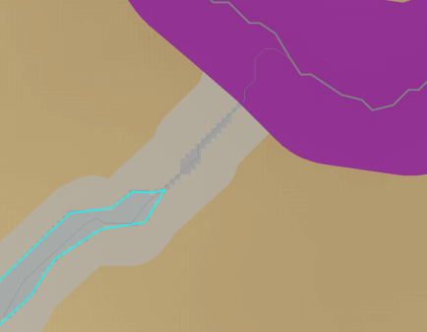
    - In some cases, the Flow To Buffer points are poorly associated with the resulting Buffer Catchment. Two circumstances were discovered: 1) the watershed boundary is very narrow as the flow path approaches the buffer, so that when the watershed raster is formed it is only one or two cells wide, and so when the watershed raster is converted to a simplified polygon, the intersection between the point and the watershed polygon is lost. 2) When the flow path moves in and out of the stream RMZ, typically in a unconfined channel where topography doesn’t necessarily align with channel position. This is likely not a problem as it identifies areas where small alluvial plains result in strong interaction between the channel and the surrounding physio-hydrographic landscape. Using the method of association by attribute join, rather than spatial join resulted in clear correspondence between point and watershed.
- Integrate Catchments
  - The following polygon feature classes are integrated into the final hydrologic polygon set.
    - FloodplainUnits – including divisions and elevation polygons
    - FloodplainCatchments which contain
      - BufferCatchments
      - StreamsideCatchments
    - ValleyWallCatchments – which are the spaces between FloodplainUnits and FloodplainCatchments
    - IntegratedBuffers – that include BufferType, WaterType that overlay the catchment mosaic
  - The following sequence is used
    - To define the whole extent of catchments, take use FloodplainUnits to ERASE floodplainCatchments, and then Union, with no gaps.
    - Clean attribute data, to provide the following attributes
      - Unique polygon ID for each unit.
        - ConcBufferCatchment is defined by PointLinkID
        - DispBufferCatchment is defined by FeatureID
      - FloodplainCatchment ID is retained for internal features, and is associated with the FlowPoint
      - [Area] in acres for every catchment
      - [Buffer] describes if the polygon is located in a hydrologically important zone (In Buffer, Out of Buffer)
      - [BuffType] describes the watertype of the buffer: (Fish, NonFish, FlowPath, None)
  - Floodplains separated from other catchment types. Only AUs are used to divide
  - AUs with coding for system and Basin
  - Floodplain with coding for Alluvial Plan and FloodZone
  - Flow to Alluvial Plain Catchments
  - Complete FlowToBuffer Catchments
  - Sub-Catchment based on stream order
  - Catchment divisions based on ridge line

Projection
NAD_1983_StatePlane_Washington_North_FIPS_4601_Feet
WKID: 2285 Authority: EPSG

Projection: Lambert_Conformal_Conic
False_Easting: 1640416.666666667
False_Northing: 0.0
Central_Meridian: -120.8333333333333
Standard_Parallel_1: 47.5
Standard_Parallel_2: 48.73333333333333
Latitude_Of_Origin: 47.0
Linear Unit: Foot_US (0.3048006096012192)

Geographic Coordinate System: GCS_North_American_1983
Angular Unit: Degree (0.0174532925199433)
Prime Meridian: Greenwich (0.0)
Datum: D_North_American_1983
Spheroid: GRS_1980
Semimajor Axis: 6378137.0
Semiminor Axis: 6356752.314140356
Inverse Flattening: 298.257222101

The following characteristics of the landscape inform our riparian management strategy:
- Fish Use – best available information is from WDFW Fish Distribution data. More detailed data are available to describe spawning areas. Rearing is inferred from habitat conditions, with different species selecting different rearing environments.
  - In areas of We restore channel structure where it provides spawning and rearing services. is
- Vegetation – We consider the condition of vegetation both in the near-stream zone, and in the catchment. County Land Cover data is available with 8 foot pixels.
  - Respond to Stressors - We intensify our riparian management efforts to compensate for land use impacts.
    - Sediment and Fecal Management – in systems with lots of tillage we consider on-farm mechanisms for capturing sediment and surface runoff.

  - Cut Losses - At some point we “cut our losses” and focus on impacts with the greatest downstream effects, or focus work in other catchements where greater return on investment can be assured.
- Active Farming – in floodplain settings we design floodplain reconnection to protect farm viability.
- Water quality parameters – we intensify efforts in areas with measurable water quality violations.
- Cold Water Refugia – we prioritize channel restoration in the vicinity of cold water refugia, particularly for pool formation. We intensify wetland enhancement in the catchments of cold water refugia to protect groundwater recharge.
- In-channel habitat conditions – we use channel restoration where deforestation has led to channel widening
- Reach geomorphology – we locate floodplain reconnection and in channel work based on how we expect that reach scale aggredation, incision, or avulsion may cause the site to evolve over time.

Ultimately riparian work is played out at a parcel scale, with a willing landowner. Spatial analysis helps us know where to engage landowners with different strategies.
The following components of the hydrological network are used to evaluate the hydrological context of an individual parcel.
Streams – Water flows downhill, conflating to form streams. Some of these streams flow year round, and others only during a rainstorm. Each segment of the hydrologic network has a catchment—an area of land that drains to the line. The condition of that catchment further affects the segment. All segments form a continuous flow—whether seasonally, or above or belowground, upstream segments affect downstream segments. We evaluate four types of streams as part of our riparian network, in order of upstream to downstream:
- Concentrated Flow Paths (50’ buffer where an area greater than 5 acres drains to a point.) – these are the topographic pathways that concentrate water, until a stream is formed stream. These corridors capture most of the rain, and are where groundwater recharge occurs
- Non-fish-bearing Streams (Np/Ns - Perennial and Seasonal – 50’ buffer) – these are small perennial or seasonal channels that flow into our fish bearing streams.
- Fish-bearing Streams (non-salmon-bearing) (F - 100’ buffer) – these are the perennial tributaries to the larger streams and rivers.
- “Shorelines of the State” and Salmon-bearing Streams (S/F - CAR 150’ buffer) – these are the larger streams and rivers, frequently associated with floodplains.
Floodplains – Floodplains are unique in their soils, hydrology, and functions, and are separated from watershed areas for analysis. Within floodplain analysis we aim to consider both existing channels, potential future channel position (Channel Migration Zone), and the area wetted by different levels of flooding. In addition, many floodplains have levees, sometimes maintained by special districts, and these systems may affect how we manage the riparian zone.
Unit Type
A variety of polygons are constructed to describe various surfaces within the hydrologic landscape. Each surface is associated with some kind of stream (or absence thereof). In addition a polygon may be a “near-stream” unit or a “catchement” unit. These units may be nested, such that “near stream” units can be considered as part of the “catchment” of a higher order stream channel.
Confinement | StreamType | Proximity
Floodplain | Shorelines | Near-stream
Watershed | Fishbearing | Catchment
 | FlowPath

The catchment is defined by the point at which the stream flows into the next lower component of the network.

Polygon Characterization
Our analytical method produces two kinds of polygons. A near-stream polygon (buffer) and a catchment polygon. Each polygon is characterized using a number of metrics that describe the social, ecological condition of the catchment.
- Polygon area – catchment area is highly variable, and depends on complex post-glacial topography, and so has not intrinsic value. Catchment area does describe the amount of runoff that will enter the stream buffer at the pour point. Large catchments exert a greater effect on water quality and quality than small catchments. Polygon area is also used to calculate land cover percentage metrics.
- Stream length – the mapped stream density describes the degree to which a catchment tends to produce runoff. Surface soils that tend to rapidly saturate and produce overland flow will naturally form a higher channel density.
- Concentrated flow path length – the concentrated flow path density describes the extent to which topography conflates surface flow into confined pathways, as opposed to landscapes where flow concentration is poorly developed.
Degradation Metrics
- Road length – all roads are assumed to both generate runoff of perhaps 5 or 10 times forested landscapes, and through ditch systems, concentrate that runoff at low points that coincide with flow paths. In this way, roads effectively expand the drainage network within a catchment.
- Percent Impervious – The proportion of impervious land cover describes the degree to which development is producing Stormwater.
- Percent Cleared – the proportion of the polygon that is neither forest nor wetland describes the gross degree of vegetation modification.
Water Retention Metrics
- Depression Volume – in processing digital elevation models for routing flow, we fill areas that drain nowhere. The volume of this fill area describes the degree to which the landscape is likely to retain surface runoff due to irregular topography. Some of this irregularity may be related to data error, and so this metric is not precise, but provides a general order of magnitude. There should be a correlation between depression volume, percent wetland, and slope.
- Average Slope – average slope within the catchment describes the rate
- Percent Wetland – The area of
- Percent Forested – Describes the like
- Percent Open Water
Social Dynamics
- Average parcel size – the average parcel size describes the intensity of community settlement in the catchment. The parcel size is an attribute of the parcel, and this attribute is averaged for all parcels in each polygon. (There is some complexity here, as the analysis
- Mean potential parcel size (zoning)
- Percent forest cover loss

- Snohomish DEM
- Ecology PSWC Assessment Units
- CLIP DEM to Middle Pilchuck Assessment Units
- FILL Pilchuck DEM
- CUT FILL between original and filled DEM
  - While there are scattered fill points, there are large areas associated with floodplains, lakes, and impoundments behind transportation infrastructure earthworks.
- SLOPE of filled DEM
- FLOW DIRECTION of filled DEM
- FLOW ACCUMULATION of filled DEM

