Analysis of Culvert Replacement Permitting in Snohomish County
Paul Cereghino, NOAA Restoration Center

Analysis of Culvert Replacement Permitting in Snohomish County 1
Introduction 1
Scope of our Work 2
Our Targets 2
Regional Transportation System Context 2
Decision Context 2
Risk Assessment by Ecosystem Component 3
Possible Alternative Outcomes 5
Parking Lot of Claims 5
Regulatory Dynamics 6
Related Issues 8
December Work Session 9
Attendance 9
White Board Notes 10
Next Steps? 11
Areas with Greatest Potential for Improvement? 11

Introduction
The purpose of this effort is to define optimal regulatory processes for culvert replacement that supports Puget Sound recovery in Snohomish County. These should be least-cost procedures for upgrading the culvert network while enhancing protected resources.
This work session is being conducted with support of the Coordinated Investment effort (CI) and is being tracked by the Puget Sound Federal Task Force, Results Washington Goal Council 3 and the Ecosystem Coordination Board. The overall CI effort uses integrated local efforts to review and improve the state and federal ecosystem recovery operating environment, so we can achieve more public benefit for less cost by improving existing systems.
Regulatory review of culvert replacement may consider landscape context, cumulative effects, or resources that may be outside the expertise or interest of a road maintenance system engineer. Each agency must ultimately make an independent decision about how to implement the intent of its authority. Our assumption is that by developing a clear and shared strategy for addressing protected resource concerns we can minimize effort spent generating and revising submittals and debating the documentation of avoidance or mitigation of de minimis impacts. If we can develop this shared strategy, we can focus our resources on building projects that solve problems.

Scope of our Work
The System We are Managing is: The process by which a party replacing a set of culverts in Snohomish County gets permission from local,state and federal regulatory agencies to proceed with work, including design, submittal preparation, review, and the resulting aggregate BMP regime. We will develop a least-cost strategy under existing authorities that will replace ten to twenty culverts per year, and can scale up both within Snohomish County and serve as a model for the Puget Sound region.

Our Targets
- Agencies meet and document their requirements under regulatory law
- Protected resources are enhanced in an efficient way
- The cost to the public for review is minimized
- Both agency staff and design teams have a shared vision of best practices
- We continuously identify and improve processes that create cost without solving #1 or #2.

Regional Transportation System Context

Culverts at stream crossings are the critical location where our transportation system, with its support for development, hydrologic modification, and stormwater toxins directly intersects the stream ecosystem, with significant aggregate effects on stream ecosystems.

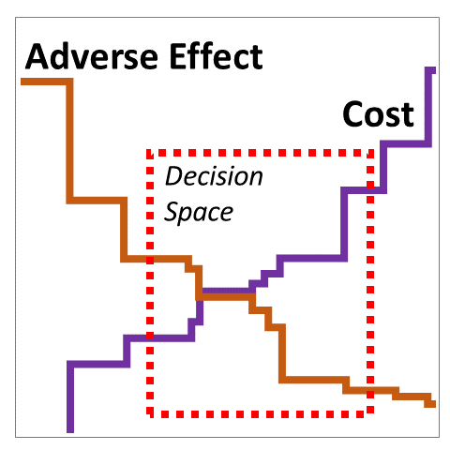
Decision Context
The regulatory review process is a negotiation over the cost-benefit ratio at each site. In general there is not a large discrepancy between the transportation engineers intent and the regulatory reviewers intent, but rather a relatively small difference in interpretation of adverse effect, and a different ability to accomodate increased costs.

Risk Assessment by Ecosystem Component
Parallel Coordinate Investment work suggests nine freshwater ecosystem components that are protected by local, state, and federal authorities. Given the complexity of the “regulatory ecosystem” we propose integrated risk assessment organized around these nine components. The implied hypothesis is that projects with higher risk should receive more review effort (even as we still seek to maximize efficiency of all review so that we can apply more of our resources to construction).
- In-Stream Habitat Functions - Culverts are a discontinuity in the stream system. Altering this discontinuity can trigger channel evolution and sediment/wood transport processes, or initiate erosion processes that propagate up or downstream of the site. Risk assessment could be based on considering the size of the catchment (discharge), reported fish presence, and estimated slope of the reach (power) compared to estimated slope at the culvert (slope discontinuity).
- Riparian Zone - Culvert replacement may result in destruction of desirable stream buffer vegetation, and provides an opportunity to complete work to enhance that vegetation. Risk assessment is likely not necessary, as vegetation impacts can be resolved for any site through standard design criteria and BMPs, and vegetation enhancement is a typical part of culvert replacement.
- Flood Damage Risk - High in the watershed, culverts and their associated road causeways provide opportunities for stormwater retention and the mitigation of watershed development. On higher power streams, culverts may increase downstream erosive power, as new large culverts fully pass wood and water, increasing downstream erosion risks during storm events. Risk assessment could be based on similar attributes as in-stream habitat--however cumulative effects of drainage improvement of downstream flooding are likely not part of culvert program design. Opportunity assessment could be based on the presence of low average slopes in the upstream vicinity of the culvert and the presence of wetland polygons, which may indicate opportunities for storage.
- Floodplain Habitat Functions - Many floodplain habitat functions are described by riparian, in-channel, hydrographic, wetland or other components. In addition, a culvert-causeway system may constrain channel migration processes that create and sustain habitat function. Typically, transportation causeways exist before the project, and are retained after the project, and so in most cases there is no change in environmental condition. Risk and opportunity assessment could be based on presence of channel migration zone where available, or otherwise location within an alluvial plain polygon.
- Water Quality - Culvert replacement may have short term effects on turbidity. Backwater effects from culverts may have beneficial effects by creating settling ponds or wetlands, mitigating upstream water quality problems. A culvert replacement may initiate erosion processes that create a chronic increase in turbidity (described under the in-stream section). Risk Assessment of water quality is likely not necessary, as risks are controlled on any site through standard design criteria and construction BMPs.
- Hydrography - Where culverts result in backwater effects, they may serve as minor live storage features that mitigate upstream hydrologic effects of forest clearing and development, and distribute a flood surge over time. Risk and opportunity assessment would consider the same variables as in-stream habitat, but for the purpose of screening sites where the culvert effects are primarily to accelerate drainage.
- Wetlands - Culverts may occur in natural wetlands, or in wetlands created by a road causeway itself. Culverts are a technology to convey water, and thereby may reduce retention of water in adjacent wetlands system. Risk assessment could be based on the presence and size of wetland polygons adjacent to the culvert using county high-resolution and cover data, and google ground photography.
- Fish and Wildlife Populations - Culvert replacement may radically improve the quantity of habitat available to a population by removing a fish passage barrier. There is a short term risk to individuals during construction. Construction blockage of fish passage during anadromous migration may have dramatic population effects. Risk assessment is likely not necessary, as risks may be controlled on any site through standard through construction BMPs. Opportunity assessment will hopefully be transparently integrated into County project selection.
- Cultural Resources - Culvert replacement typically has a low risk of impact to historical resources, because ground disturbance is generally limited to recent fill or alluvial sediments. Risk assessment is likely not necessary, as risks are controlled through construction BMPs.
There may be numerous opportunities to increase ecosystem services at culvert sites. Based on this assessment the following variable factors appear to be the primary drivers of risk:
- Stream Power - Higher stream power (a function of discharge and slope) creates erosive potential that can create changes in stream form in response to the in-channel modification. In addition stream power affects the turbidity plume associated with re-watering the modified channel, and may result in rapid and significant evolution of channel structure, with a change in water, sediment and wood transport through the culvert. Stream power affects the potential for water quality impacts (5), and for interruption of stream processes that form habitat (1)
- Fish Population Use - systems with anadromous natal spawning migration pose the greatest risk, particularly from delayed construction. In addition areas with high levels of juvenile rearing have higher risk.
- Wetland Presence - modern culvert replacement involves large diameter pipe. In flat landscapes existing wetland functions and biota may be adapted to drainage restrictions created by existing culverts. Increasing drainage restores ecosystem processes in some systems, but may affect wetland functions in other settings.
- Road-Stream Alignment - the orientation of the stream flow in relation to the road creates a range of engineering challenges to pass water, wood and sediment, while minimize potential damage to either stream or road.

Possible Alternative Outcomes
We are not anticipating that this workshop will be conclusive. It makes sense however to start considering the endpoint of our work. Is this an accurate summation of the alternatives?
- Handshake Agreement - At the end we could just write up what we discovered, and agree that conducting business in this particular way is mutually beneficial, and share that with leadership. The challenge is that there is continuous rotation among leadership and staffing at all agencies, and so this outcome is unlikely to be durable, and would be less likely to decrease documentation, as very limited risk sharing could be achieved.
- Memorandum of Understanding (No Regulatory Determination) - This outcome would define “rules of engagement” as above, and may involve a more formal agreement among agency leadership. This would necessarily require that the agreement be more detailed and concise. This would increase durability, and the potential to share risk, but applications would still go into an existing regulatory que, but with more clarity and certainty about process and outcome. This outcome aims to maximize the flexibility of regulatory programs, short of drafting new programmatic authorities.
- Programmatic Regulatory Agreement - This would likely require a higher level of quantification and reporting, and therefore more time and effort spend of defining the agreement. It would increase independence on the part of Snohomish County, but at a high cost. Not all parties may be interested in a county-scale agreement. Some kind of mitigation program at the county could increase the range and scope of such an agreement. This mechanism already exists for NOAA and WDFW, and so the parties most affected would be County PDS, USACE, and Ecology.

Parking Lot of Claims
For the purpose of creative analysis we are acknowledging but setting aside some issues we have identified during interviews. While these issues may be personally or politically meaningful, they do not appear to support creative collaboration at this time.
- Change in USACE Policy Complaint - I have heard a variety of claims that USACE has changed its procedures for issuing Clean Water Act maintenance exceptions. While this may or may not be accurate or precise, this claim does not appear to contribute to solving the existing problem, since USACE reports having existing policy about determining exemption. It is clear that USACE submittal (not to mention review) creates a substantive increase in cost.
- Engineer’s Authority Complaint - I have heard a complaint that regulatory review does not improve design, since engineers already stamp culvert plans, designed according to accepted culvert design standards. Given the legal requirement of agency staff to make determinations, and variable experience among transportation engineering staff and systems, this claim presented as a general rule, doesn’t contribute to problem solving. We instead have the objective to reduce review costs that do not add public value.

Regulatory Dynamics
Regulatory dynamics are best described as a series of pathways beginning with a project description and submittal, and ending with a set of permits. The details of the project create a sequence of notification-analysis-response events. The primary increase in cost is 1) when a project passes a threshold or triggers a new authority requiring additional submittal, or 2) when the information necessary for analysis is not present or found, requiring repetition of a sequence. An optimized system would generate only the submittals necessary for analysis, but contain all the information necessary for analysis in a predictable format.
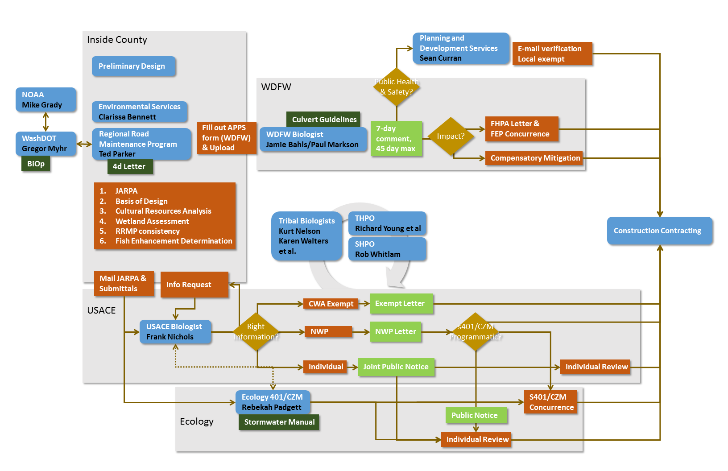
- Hydraulic Project Approval (WDFW) -
  - GHPA Pathway -
  - FHPA Pathway
  - HPA Pathway
  - WDFW has issued a General HPA for road maintenance and conducts a beginning of season consultation with Snohomish County and interested Tribal representatives.
  - This early “design review” may provide value for other agencies to conduct business.
  - WDFW does not currently participate in the Regional Road Maintenance Program.
- Section 401 Clean Water Act Certification (WDOE)
  - Where USACE assumes jurisdiction over wetland review, Ecology’s primary review during federal determination is to insure adherence to clean water act water quality standards and monitoring. Procedures for workplace isolation and reconnection of flows to minimize the turbidity plume are relatively uniform, although variation can be caused by unexpected construction scenarios.
  - Section 401 review follows a USACE determination of how 401 authority should be applied.

- State-owned Aquatic Lands Review (WDNR) - streams with culverts are rarely state-owned aquatic lands.
- Section 404 Wetland Review (USACE)
  - Jurisdictional Review
  - Connectivity
  - Fill
  - Coordination
    - ESA
    - S401
    - S106
    - Tribes
  - S10 Pathway
  - S404 Pathway
    - USFWS ESA
    - NWP tribal notification
    - IP public notification
  - We anticipate this is the pivotal authority affecting the time and cost of regulatory review.
  - Determination of federal jurisdiction results in a substantive increase in document preparation, review time, and a high potential for additional information requests.
  - USACE has a narrow authority to consider project exempt from Clean Water Act review where there is no change in “slope, character or size” of fill. USACE has asked to be provided information to determine if a project meets that exception. Some agencies have chosen to not submit a project based on their own determination of consistency.
  - USACE staff have a large backlog of review. WSDOT has solved this issue by using state funds to create USACE staff positions that provided dedicated review services for WDOT projects.
  - Biological and archaeological staff from eight individual treaty tribes are notified, and have an opportunity to comment and request additional information for projects under federal jurisdiction.
  - USACE interprets the ESA 4d exception as a “Not Likely to Adversely Affect” determination, limiting the use of “no report” types of Nationwide Permits (NWP) and requiring information requests to verify ESA considerations.
  - Any net loss of wetland area or function prevents use of a NWP, and requires an individual permit (IP).
  - An IP has a mandatory public review period, but can be expanded to include a larger number of projects over a longer period of time.
  - Revegetation may be used to compensate...
- Endangered Species Act (NOAA/USFWS) - Triggered by USACE jurisdiction.
  - NOAA has issued a 4d exemption for agencies participating in the Regional Road Maintenance Program including Snohomish County. This states that activities conducted by Snohomish County under that program.
  - NOAA has multiple programmatic vehicles for ESA review that could be used depending on the needs of parties, including USACE.
  - The RRMP does not cover bulltrout and USFWS species, and so presence of USFWS species
- Section 10 Rivers and Harbors Act (USACE) - this is unlikely to be a strong factor in determination and is completed as part of USACE review.
- Section 206 Cultural Resources (USACE/Tribal Governments) - culvert projects typically excavate in road prism with minimal impact on native soils. Individual tribes are notified, and have 30 days to respond, and may ask for construction supervision. Similar provisions are associated with state capital funds (section 505 review). This process may require an archaeological review cost $5,000-$15,000.
- Snohomish County Work Flow - the staff administering the Regional Road Maintenance Program, staff completing SEPA/NEPA and regulatory submittals, staff completing county environmental review, and the staff designing culverts, all work in different sections of Public Works or Planning and Development Services. This has the potential to increase costs within the county, depending on the level of process integration. This will be re-evaluated after defining the least-cost regulatory pathway.

Related Issues
Some of the issues that emerge during culvert review, are not related to immediate and direct impacts of culvert replacement, but ultimately affect review processes.
Prioritization of Culvert Replacement - Broader understanding and agreement among local partners about the overall strategy for using transportation system maintenance resources to minimize adverse impacts to trust resources may reduce the questioning that occurs during permit review, particularly among tribal reviewers.
Lifecycle and Long Term Landscape Strategy - The culvert lifecycle provides a temporal context for evaluating the effects of a particular replacement, to consider cumulative effects of culverts of fish passage, and engineering for anticipated climate change.
Mitigation at a Programmatic Scale - A modest and well documented wetland restoration and enhancement program could provide regulatory reviewers a mechanism for streamlined review of minor wetland impacts.
Stormwater System Management - The culvert network is part of a system that transports stormwater flows to streams. In integrated culvert replacement program may also provide public benefit by integrating stormwater strategies at critical locations.

December Work Session
December 13, 2017, 10:00 am - 2:00 pm
4735 E. Marginal Way South, Seattle, WA 98134
Bldg 1202, St. Joe River Conf Rm 2324

Attendance
Frank Nichols (USACE), room host | thomas.f.nichols@usace.army.mi
Rebekah Padgett (WDOE) | rebekah.padgett@ecy.wa.gov
Morgan Ruff (Tulalip) | mruff@tulaliptribes-nsn.gov
Kurt Nelson (Tulalip) | knelson@tulaliptribes-nsn.gov
Ted Parker (SnoCo) | t.parker@snoco.org
Irene Sato (SnoCo) | irene.sato@snoco.org
Erik Stockdale (SnoCo) | erik.stockdale@snoco.org
Diane Hennessey (WDOE) | diah461@ecy.wa.gov
Dan Krenz (USACE) | daniel.a.krenz@usace.army.mil
Jim Blankenbeckler (SnoCo) | jim.blankenbeckler@snoco.org
Kirk Lakey (WDFW) | lakeykal@dfw.wa.gov
Paul Cereghino (NOAA), facilitation | paul.r.cereghino@noaa.gov

White Board Notes

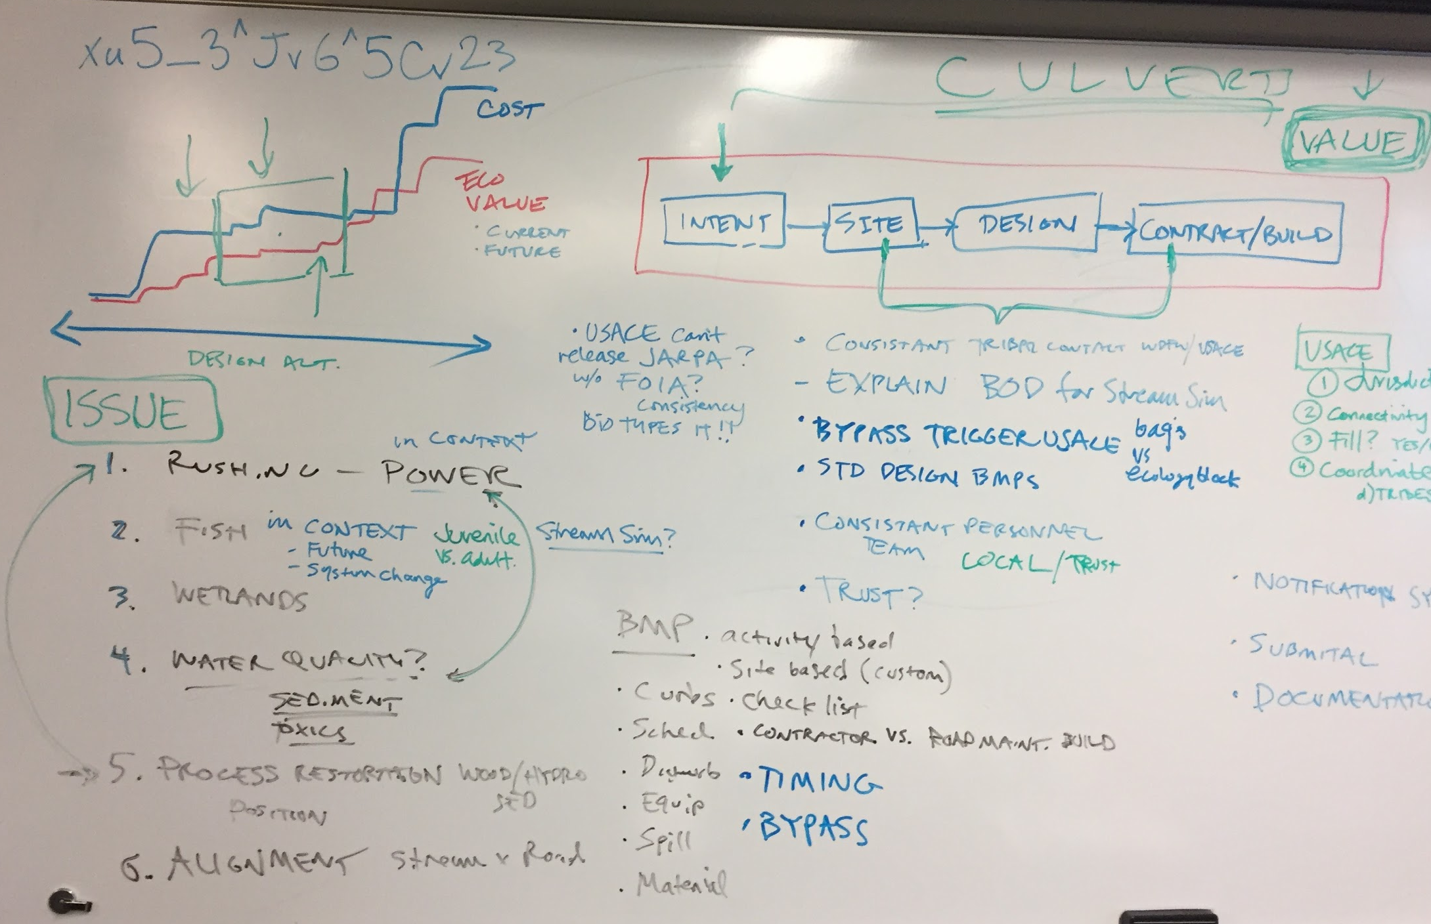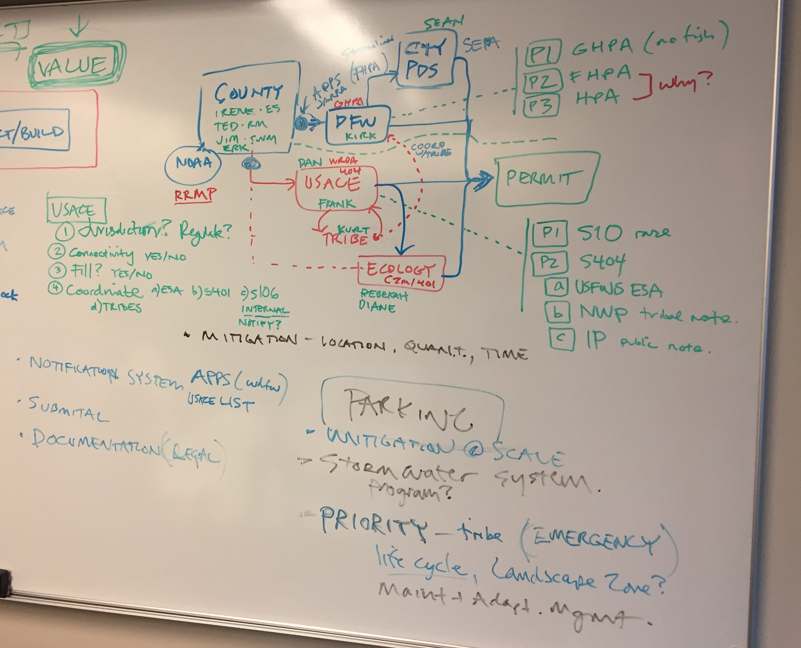

Next Steps?
- Group culvert replacement by design type
  - Grouping BMPs
  - Define regulatory pathway
  - Checklists
- Consider a “mitigation” strategy that lets you make the case for self-mitigating project portfolio with the least work.
- Define what it would it take to avoid federal review?

Areas with Greatest Potential for Improvement?
Participants provided 1-3 responses each. These responses were organized into four topics.
- Tribal Coordination
  - “ACOE distributions to tribes--defined timelines for tribal reply”
  - “Tribal notification process”
  - “Pre-application tribal coordination”
  - “Reduce back and forth with tribal comments”
  - “Early tribal coordination between tribes and applicant”
- Submittal
  - “Come to an agreement about using 1 application for all agencies for culvert projects”
  - “Clarity of application materials”
  - “Complete and clear application”
- Administration - Sequencing
  - “Pre-application meetings and consultations”
  - “Front load review -- provide info early”
  - “Do a “MAP team” approach to a batch of several to many culverts that are similar in nature. All agencies and tribes are part of it.”
  - “Review check-in steps”
  - “Information submittal steps [sequence?]”
- Administration - Pathway Management
  - “Better/consistent understanding of what triggers ACOE review”
  - “Use a programmatic individual permit for CWA 404/401”
  - “SEPA/NEPA coordination”

